LAB MANUAL

How to Installation Anaconda

Steps

Previous Next

**Step 1: (‎9/‎27/‎2023 06:06:09 AM)** User left click on "download anaconda - Google Search (document)" 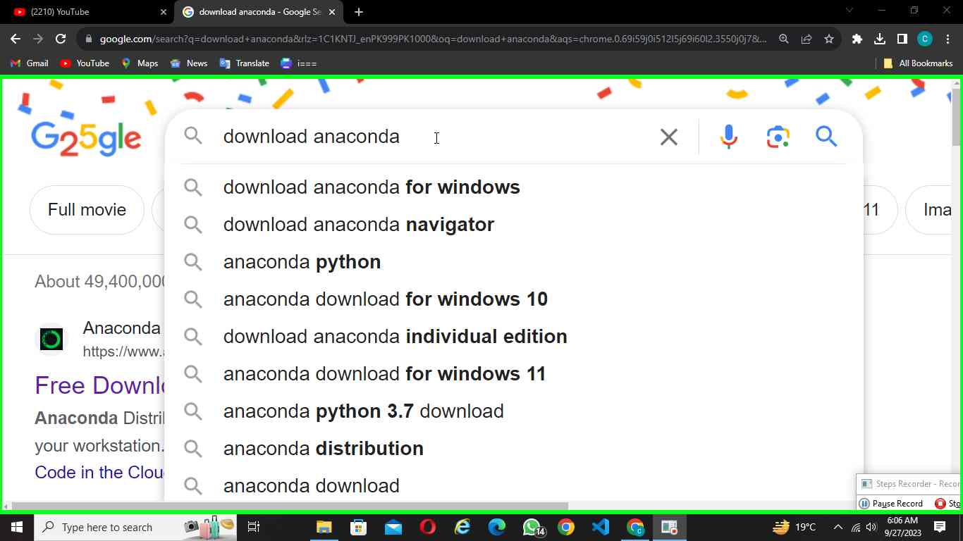in "download anaconda - Google Search - Google Chrome"

Step 1 screenshot.

Previous Next

**Step 2: (‎9/‎27/‎2023 06:06:40 AM)** User left click on "download anaconda - Google Search (document)" in "download anaconda - Google Search - Google Chrome"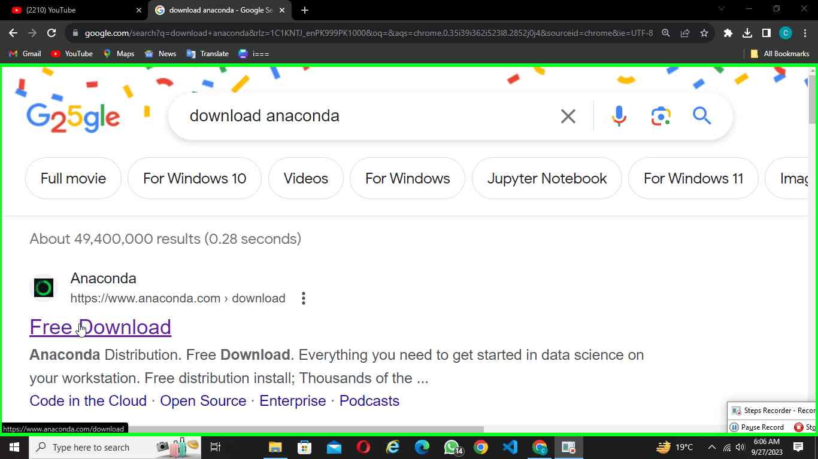Step 2 screenshot.

Previous Next

**Step 3: (‎9/‎27/‎2023 06:06:59 AM)** User left click on "Download (text)" in "Free Download | Anaconda - Google Chrome"

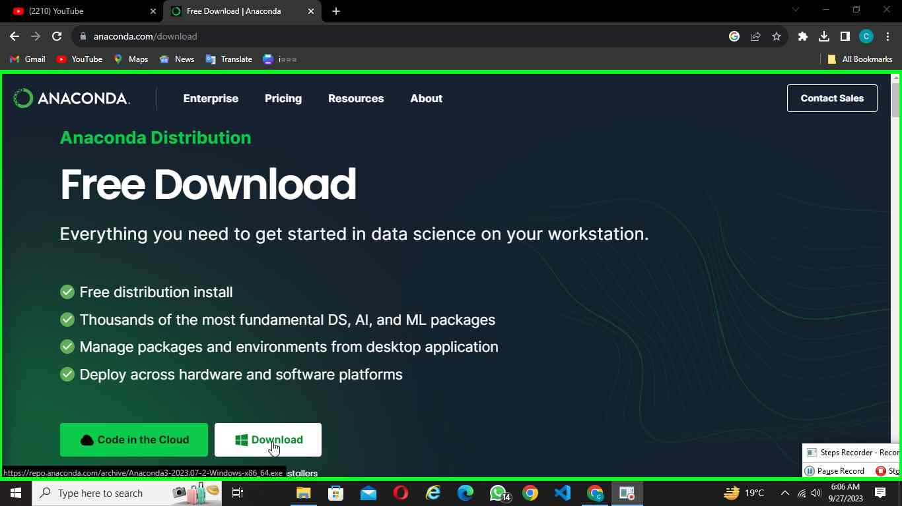Step 3 screenshot.

Previous Next

**Step 4: (‎9/‎27/‎2023 06:07:04 AM)** User mouse wheel down on "Download Success | Anaconda (document)" in "Download Suc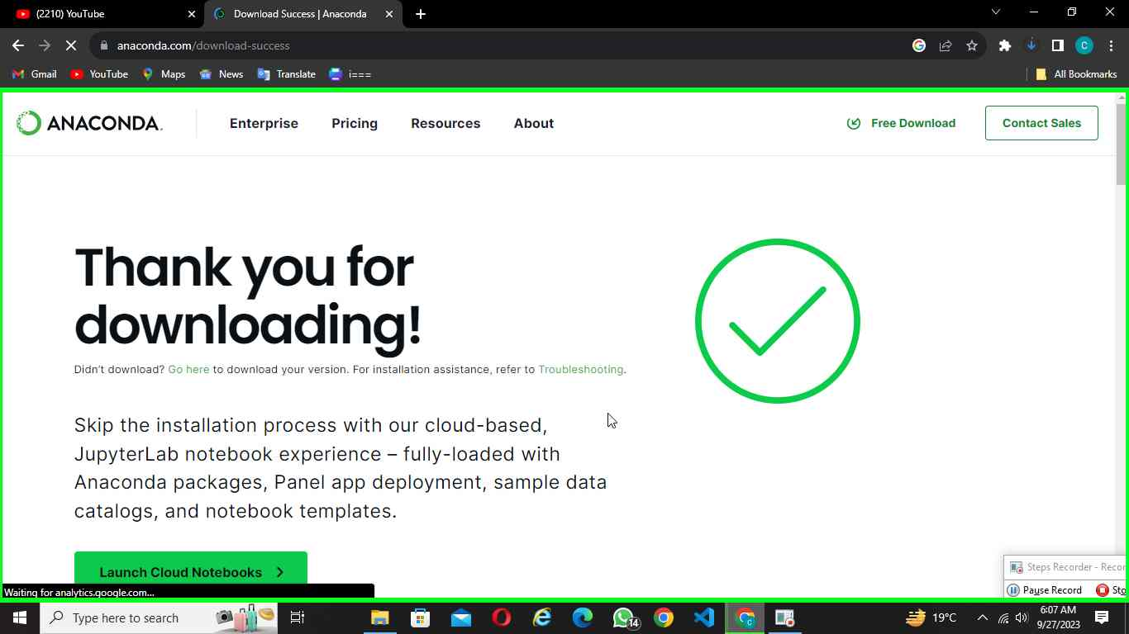cess | Anaconda - Google Chrome"

Step 4 screenshot.

Previous Next

**Step 5: (‎9/‎27/‎2023 06:07:05 AM)** User mouse wheel up on "Download Success | Anaconda (document)" in "Download Success | Anaconda - Google Chrome"

­­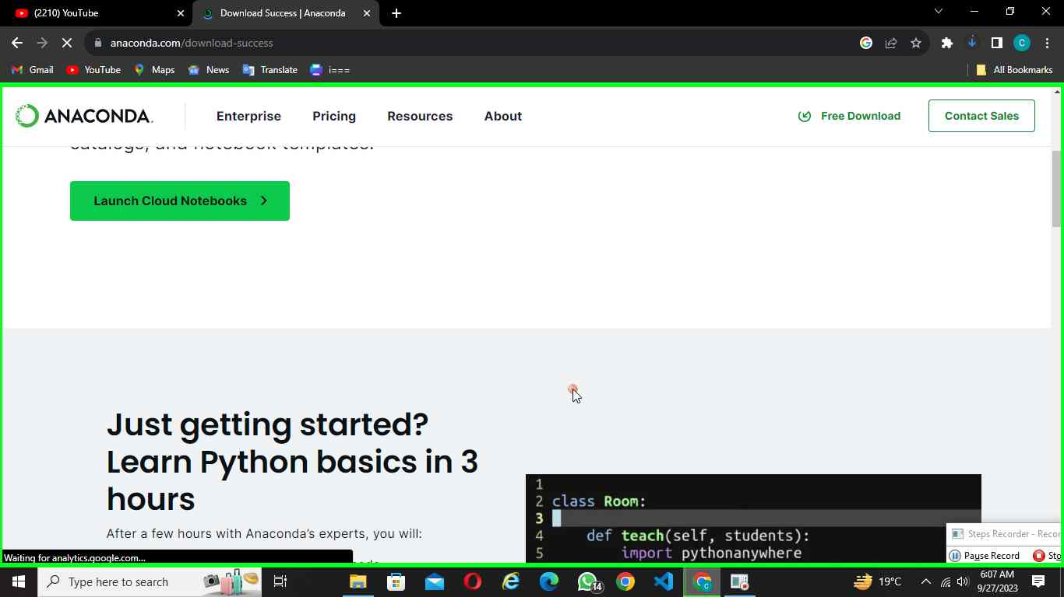Step 5 screenshot.

Previous Next

**Step 6: (‎9/‎27/‎2023 06:08:21 AM)** User left click on "Today Anaconda3-2023.07-2-Windows-x86_64.exe https://repo.anaconda.com/archive/Anaconda3-2023.07-2-Windows-x86_64.exe Show in folder Remove Anaconda3-2023.07-2-Windows-x86_64.exe from list (row)" in "Downloads - Google Chrome"

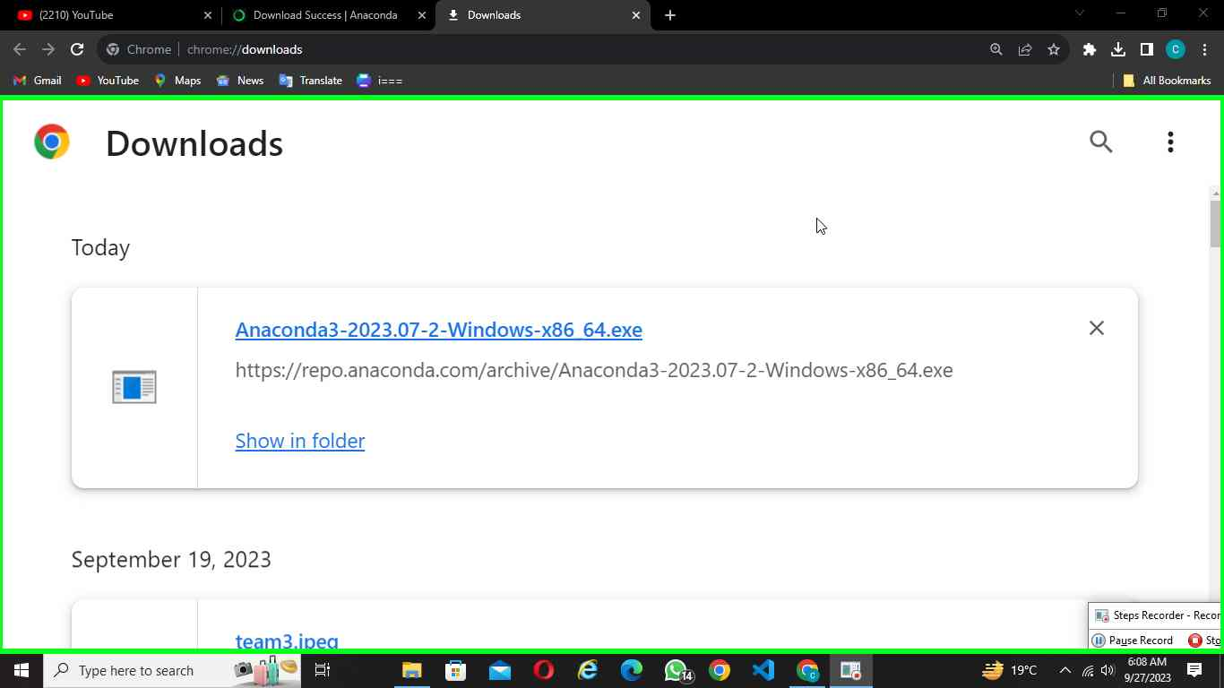Step 6 screenshot.

Return to top of page...

Next

**Step 7: (‎9/‎29/‎2023 11:15:52 AM)** User left double click on "Anaconda3-2023.07-2-Windows-x86_64 (list item)" in "Downloads"

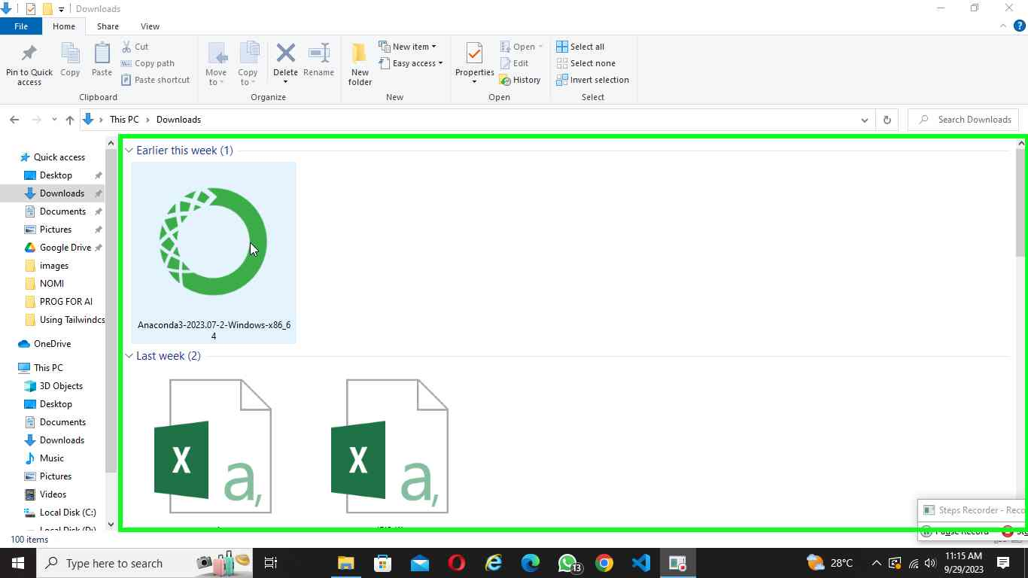Step 7 screenshot.

Previous Next

**Step 8: (‎9/‎29/‎2023 11:16:15 AM)** User left click on "verifying installer: 93% (dialog)" in "verifying installer: 93%"

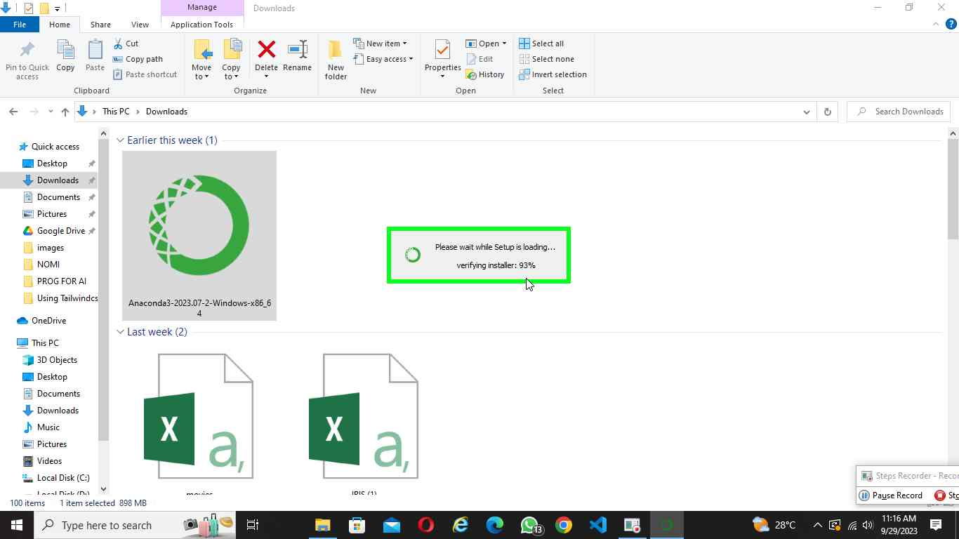Step 8 screenshot.

Previous Next

**Step 9: (‎9/‎29/‎2023 11:16:20 AM)** User left click on "I Agree (button)" in "Anaconda3 2023.07-2 (64-bit) Setup"

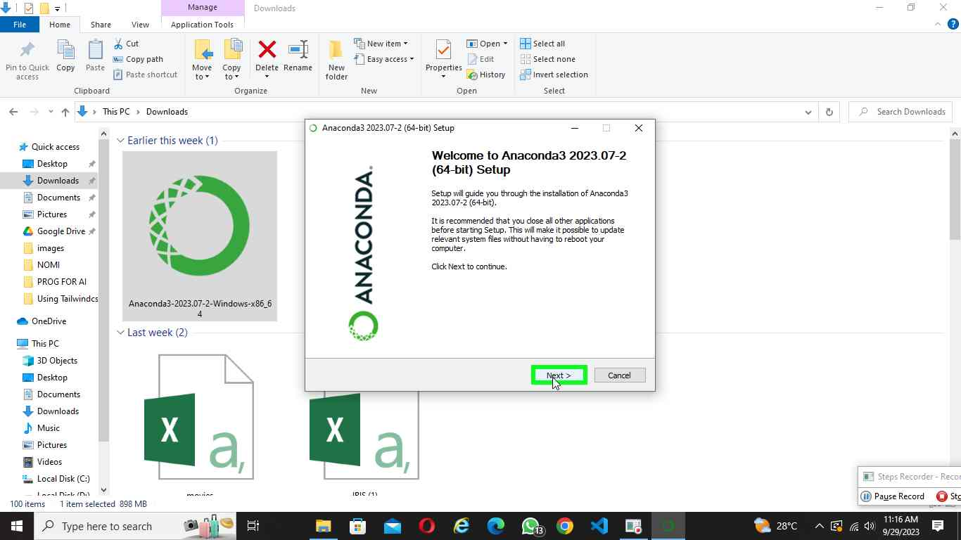Step 9 screenshot.

Previous Next

**Step 10: (‎9/‎29/‎2023 11:16:23 AM)** User mouse wheel down on "Press Page Down to see the rest of the agreement. (edit)" in "Anaconda3 2023.07-2 (64-bit) Setup "

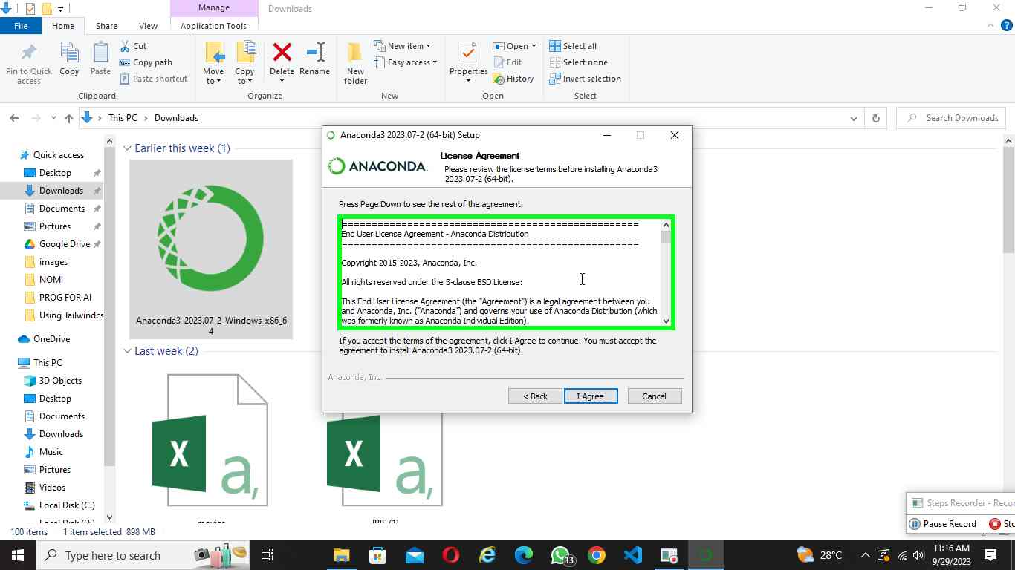Step 10 screenshot.

Previous Next

**Step 11: (‎9/‎29/‎2023 11:16:25 AM)** User left click on "I Agree (button)" in "Anaconda3 2023.07-2 (64-bit) Setup "

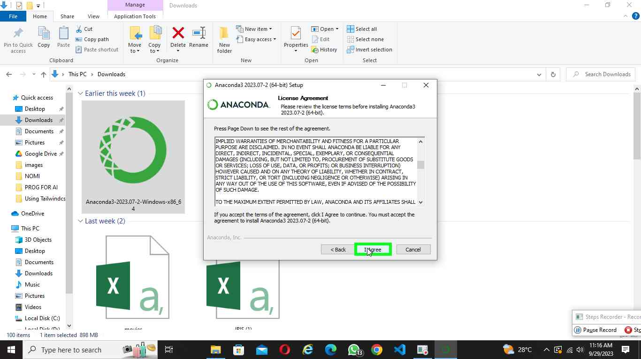Step 11 screenshot.

Previous Next

**Step 12: (‎9/‎29/‎2023 11:16:29 AM)** User left click on "Next > (button)" in "Anaconda3 2023.07-2 (64-bit) Setup"

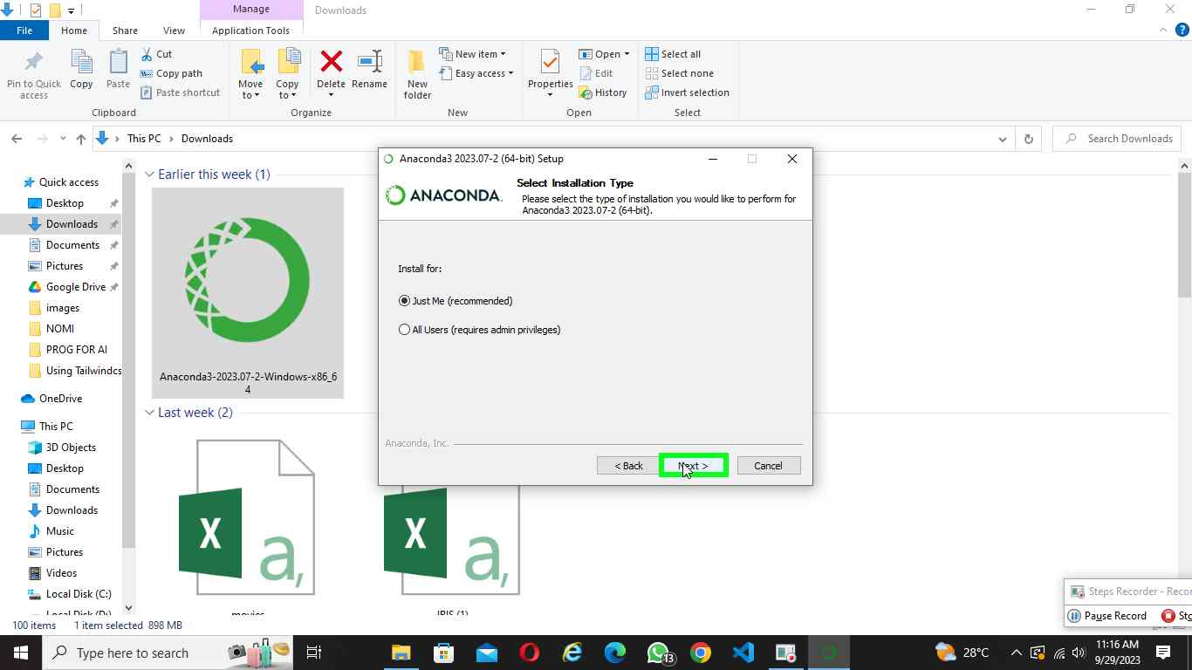Step 12 screenshot.

Previous Next

**Step 13: (‎9/‎29/‎2023 11:16:47 AM)** User left click on "Anaconda3 2023.07-2 (64-bit) Setup (dialog)" in "Anaconda3 2023.07-2 (64-bit) Setup "

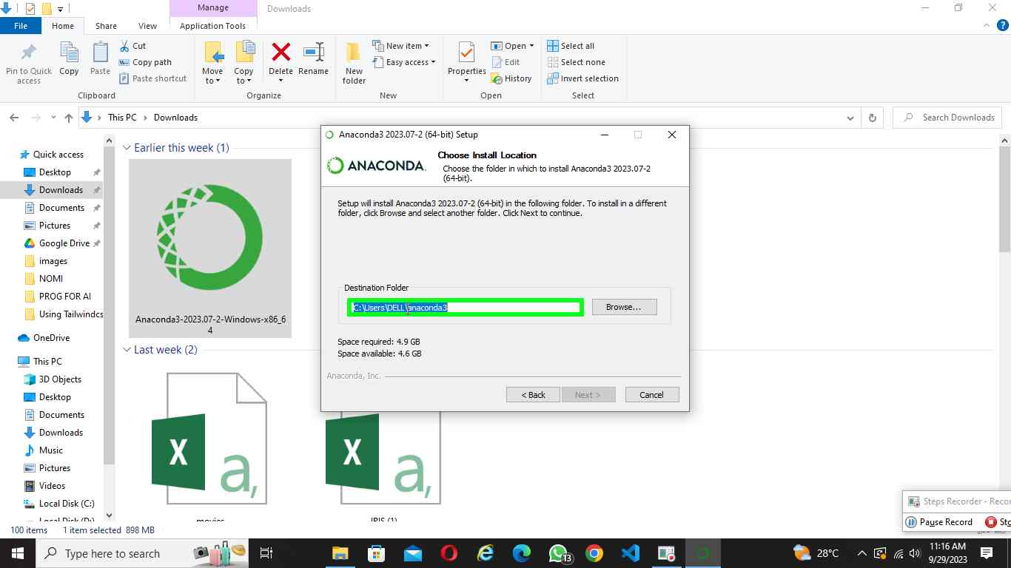Step 13 screenshot.

Previous Next

**Step 14: (‎9/‎29/‎2023 11:17:24 AM)** User left click on "Next > (button)" in "Anaconda3 2023.07-2 (64-bit) Setup "

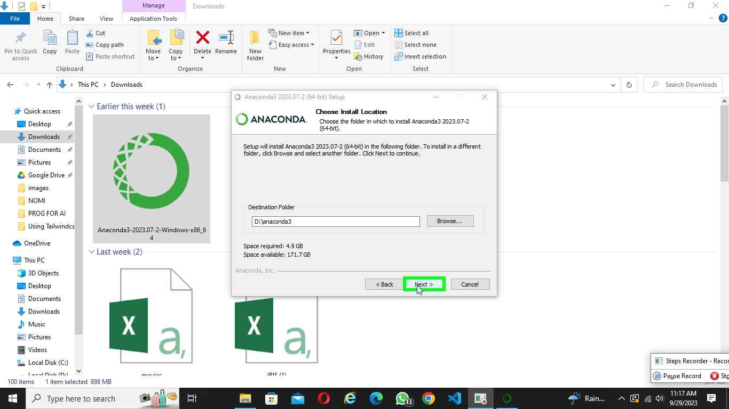Step 8 screenshot.

Previous Next

**Step 15: (‎9/‎29/‎2023 11:17:38 AM)** User left click on "Install (button)" in "Anaconda3 2023.07-2 (64-bit) Setup"

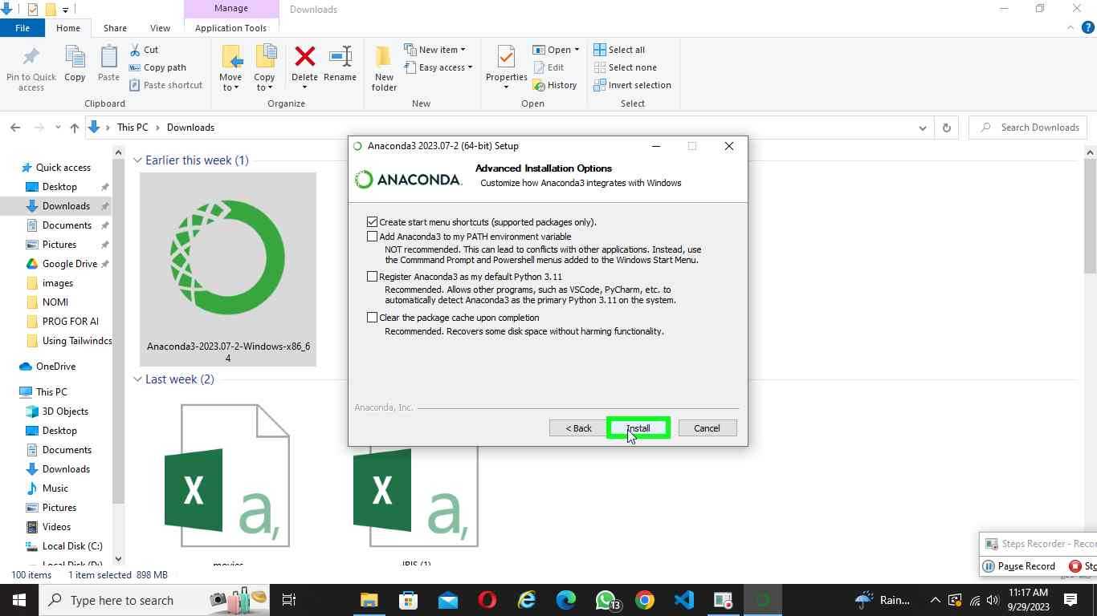Step 9 screenshot.

Previous Next

**Step 16: (‎9/‎29/‎2023 11:19:56 AM)** User left double click on "Anaconda Navigator, App, Press right to switch preview (list item)" in "Search"

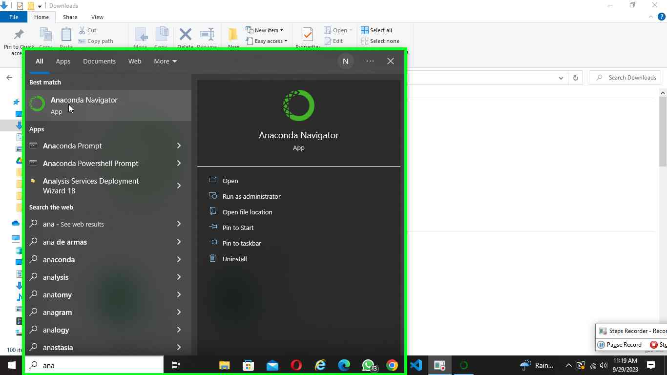Step 10 screenshot.

Previous Next

**Step 17: (‎9/‎29/‎2023 11:55:54 AM)** User left click on "Next > (button)" in "Anaconda3 2023.07-2 (64-bit) Setup "

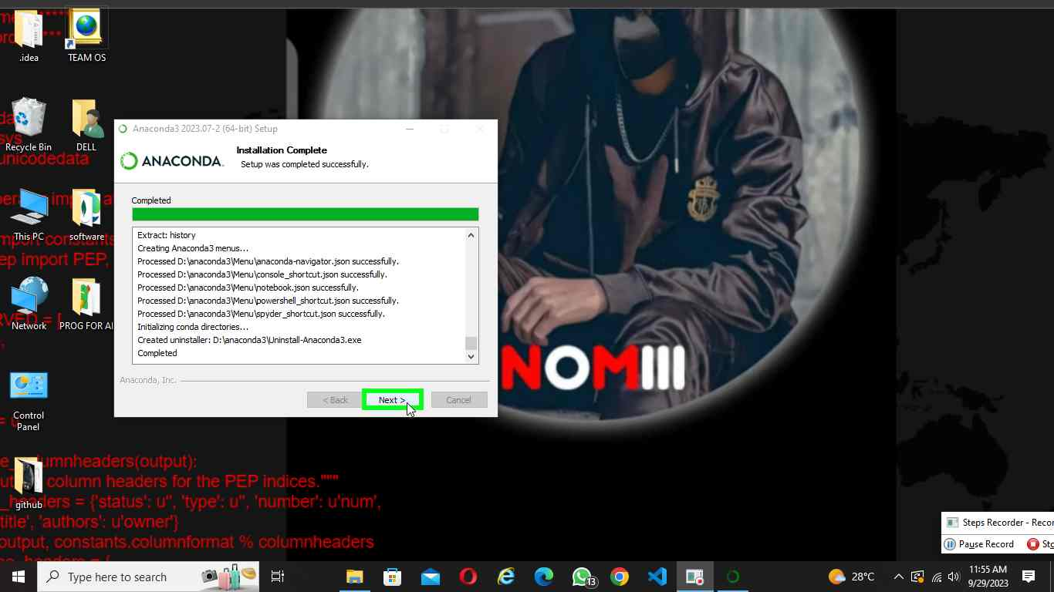Step 11 screenshot.

Previous Next

Previous Next

**Step 18: (‎9/‎29/‎2023 11:56:01 AM)** User mouse drag end on "Code with Anaconda in the Cloud (text)" in "Anaconda3 2023.07-2 (64-bit) Setup"

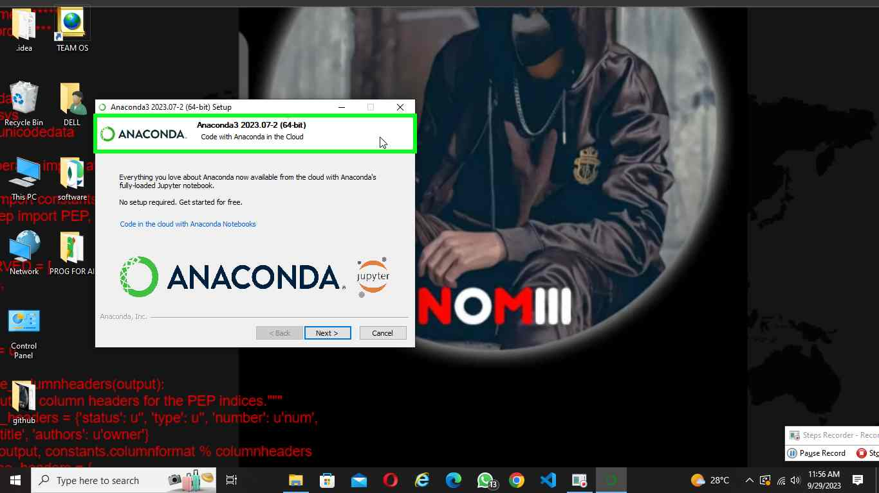Step 13 screenshot.

Previous Next

**Step 19: (‎9/‎29/‎2023 12:04:54 PM)** User left click on "Anaconda Navigator (window)" in "Anaconda Navigator"

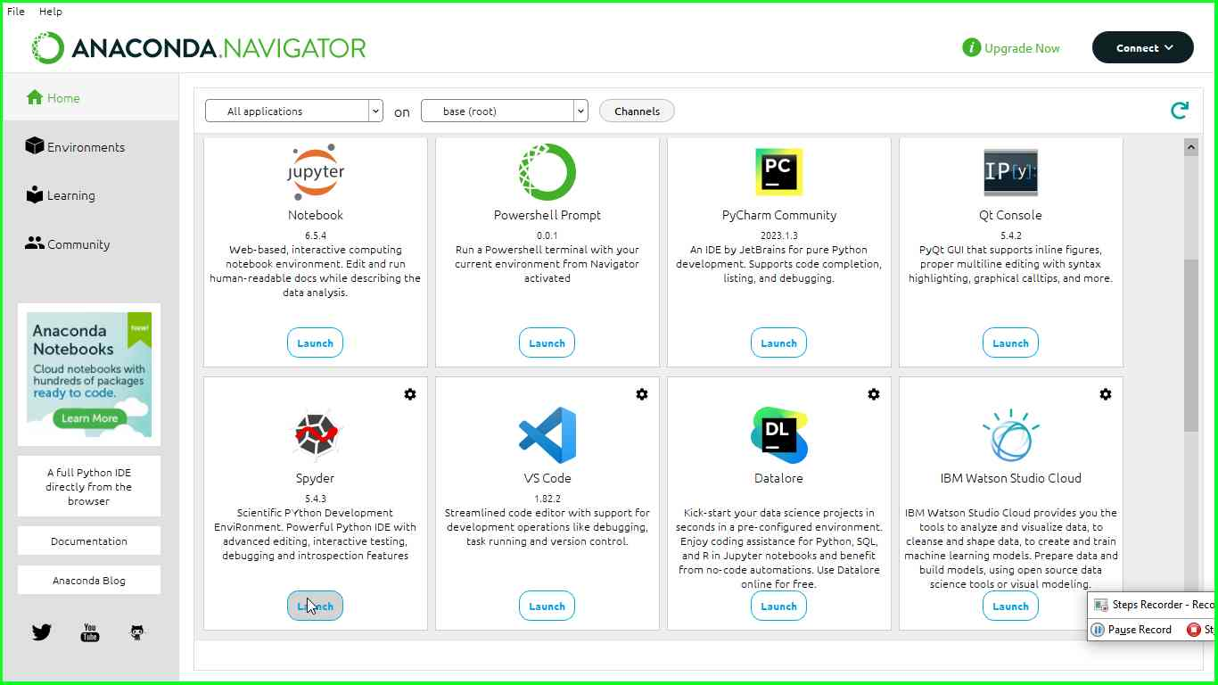Step 14 screenshot.

Previous Next

**Step 205: (‎9/‎29/‎2023 12:05:10 PM)** User left click on "Editor (window)" in "Spyder (Python 3.11)"

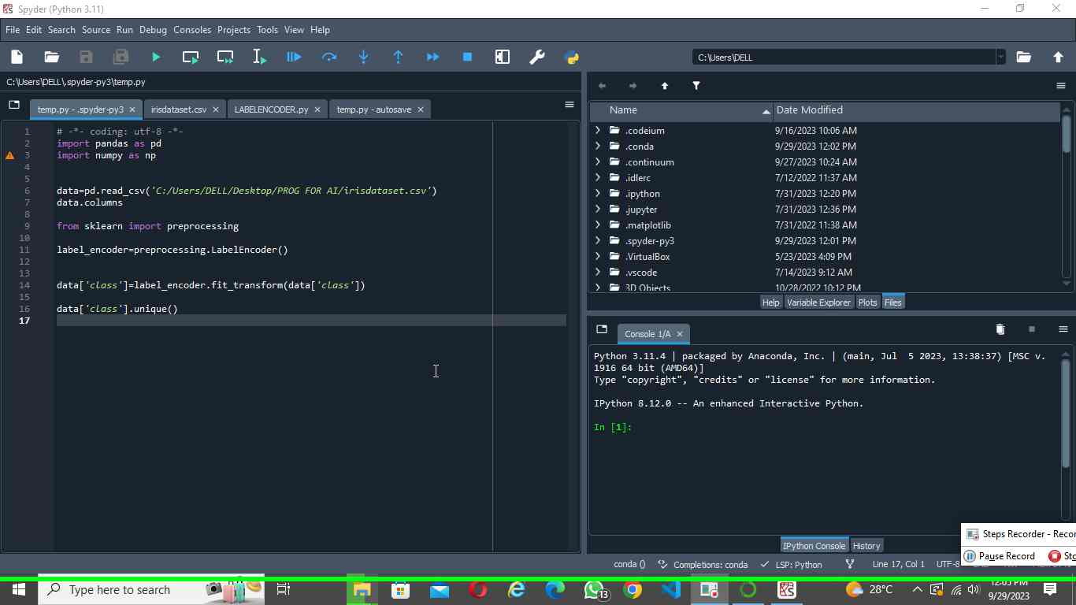Step 15 screenshot.

**THE END**